Enrollments / Case punchlist

Enrollment Reports

1. Relocate “Summary” table above other lines. So the vertical order is Group Title, Summary header and table, Period, Product, Method(s), Case Agents, and then (later) Products table  
   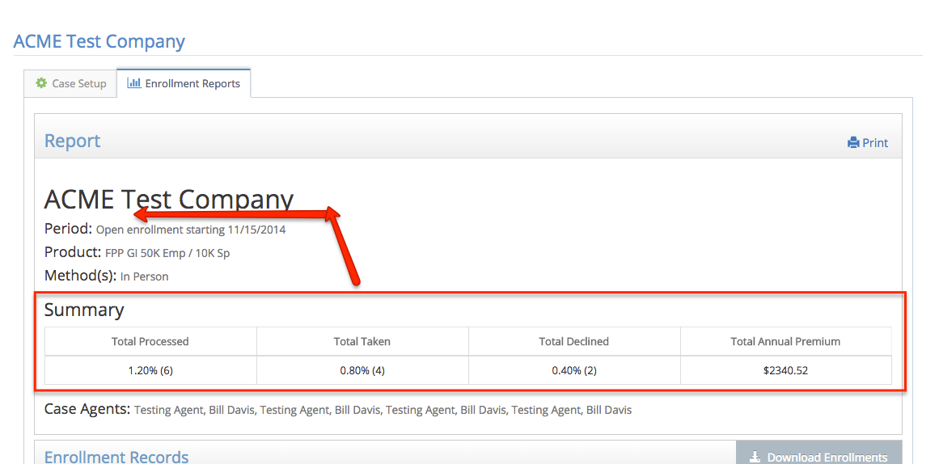
2. In “Total Processed” cell, add total number of records to parenthesis, as in  
   1.2% (6 of 500)
3. Add a new leading column, “Date/Time” with the date/time stamp (e.g., 01/27/15 15:41) – I think this is Signature Date in the file

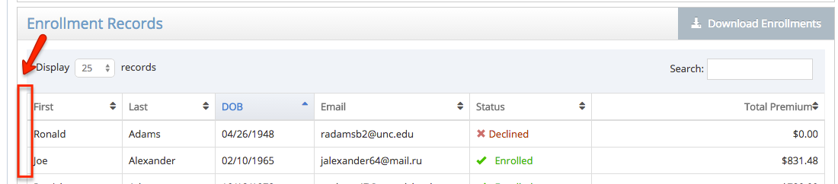

1. Download file
   1. Rename “Signature Date” header in file to be “Timestamp” and make it 1st column
   2. Make status second column
   3. Add fields
      1. Agent Code
      2. Agent Name
      3. Beneficiaries (all 4 fields)
2. BUG: Printing a report multiple time adds duplicate summary tables:  
   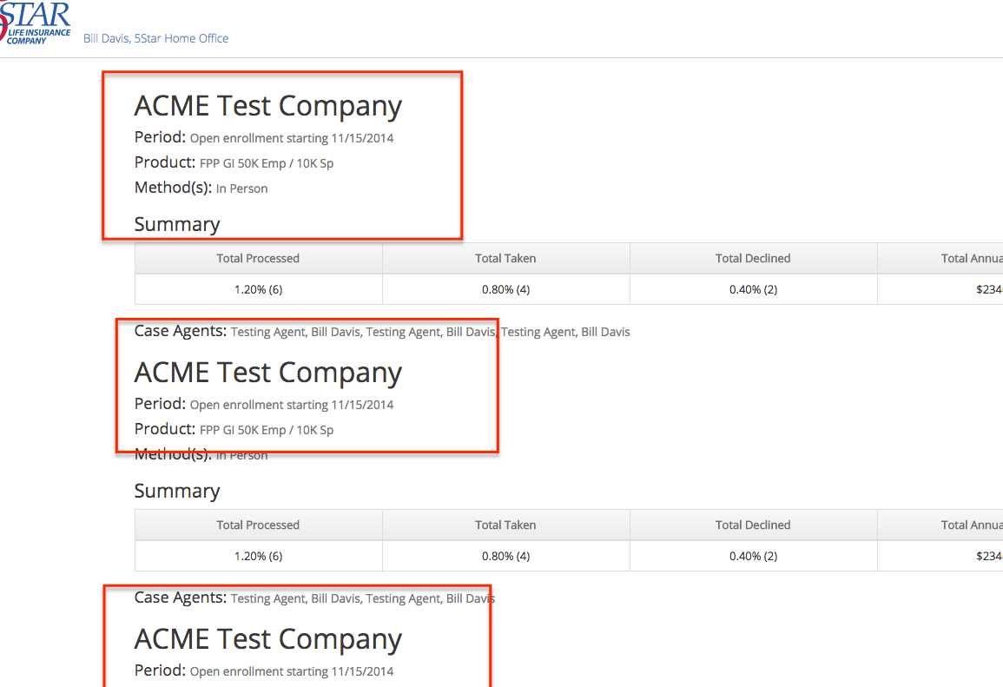
3. Can we easily just open the print target in a separate window? (or is that bad form?) Otherwise after printing the user is left on a static page with no navigation.
4. Allow Horizontal scroll on tables at <768px
5. Otherwise, would like mobile-friendly tables (perhaps for 2.5 release if there’s not a ready vehicle to do this):
   1. Breakpoints   
      I: <1024  
      II: <768w  
      III: <600w  
      IV: <560w  
      V: <480w
   2. Enrollment Records (on Enrollment Report)
      1. Default: Time, First, Last, DOB, email, status, premium
      2. At I: Time, First, Last, DOB, ~~email~~, status, premium
      3. At II: ~~Time,~~ First, Last, ~~DOB, email,~~ status, premium
      4. At V: ~~Time,~~ First, Last, ~~DOB, email, status~~, premium
   3. Case Census (on Case Setup)
      1. Default: First, Last, DOB, email, status
      2. At II: First, Last, DOB, ~~email,~~ status
      3. At IV: First, Last, ~~DOB, email,~~ status
      4. At V: First, Last~~, DOB, email, status~~
   4. Enrollment Table (on Enroll from Case)
      1. Default: button, Status, First, Last, DOB, email
      2. At III: button, Status, First, Last, DOB~~, email~~
      3. At IV: button, Status, ~~First,~~ Last, DOB~~, email~~
      4. At V we’ll rely on horiz scroll

Case Setup

1. Tried to delete existing active case with an enrollment record (“123 Testco”), and got an error “There was a problem removing this case”. I assume this is because the case had active enrollments. Is there some other situation in which we would display this message? If not, let’s either hide the delete button such a case or else use this message:  
    *Cannot delete a case with posted enrollments. Instead mark the case as ‘inactive’.*  
   whichever is your UI preference.
2. BUG (minor, could be 2.5): I created a new GI product, added it to a Case and made the case active. Then before any enrollments on the case I deleted the GI product, which left the case in an Active state with no product defined. Should make such case inactive just as if removed product from UI.
3. (minor, could be 2.5) Is it easy to make a the open enrollment start date field not have to type in slashes for the date entry (as we don’t have to for the Annual Periods fields or even birthdate fields elsewhere)?

Home-Office

1. Setup GI product
   1. If used (selected for) any case, list in new section (same style header as “Guarantee Issue Criteria” and “When GI and criteria met”) at bottom (above Delete button) “Used in Cases”
   2. After “Save” button click, return to Manage Products screen
2. Header menu should always be Home, Agents, Products, Cases, Logout  
   - these pages appear to be incorrect
   1. edituser (Agents > click a name)
   2. All the Manage Cases pages (manage-cases, manage-case,

Enrollment from Case